WordPress Plugin : Insert Script In Headers And Footers | Stored Cross Site Scripting (XSS)

Vulnerability name: Stored Cross-Site Scripting.

Vulnerability Description: The application does not neutralize or incorrectly neutralizes user-controllable input before it is placed in output that is used as a web page that is served to other users.

Impact: The attacker-supplied code can perform a wide variety of actions, such as stealing victims' session tokens or login credentials, performing arbitrary actions on their behalf, and logging their keystrokes. Stored cross-site scripting flaws are typically more serious than reflected vulnerabilities because they do not require a separate delivery mechanism in order to reach target users, and are not hindered by web browsers' XSS filters.

CWE: 79

OWASP-2017: A7

Mitigation: Input should be validated as strictly as possible on arrival, given the kind of content that it is expected to contain. For example, personal names should consist of alphabetical and a small range of typographical characters, and be relatively short; a year of birth should consist of exactly four numerals; email addresses should match a well-defined regular expression. Input which fails the validation should be rejected, not sanitized.
User input should be HTML-encoded at any point where it is copied into application responses. All HTML metacharacters, including < > " ' and =, should be replaced with the corresponding HTML entities (&lt; &gt; etc).
In cases where the application's functionality allows users to author content using a restricted subset of HTML tags and attributes (for example, blog comments which allow limited formatting and linking), it is necessary to parse the supplied HTML to validate that it does not use any dangerous syntax.

Proof of Concepts

1.Install Latest WordPress

2. Install and activate Insert Script In Headers And Footers version 2.0

3. Navigate to Settings > insert-script-in-headers-and-footers

4.Enter below mentioned payload into any of following below input fields

Scripts in Header
Scripts in Body
Scripts in Footer
Payload:- "><img src=x onerror=alert("XSS_By_Chinmay");>

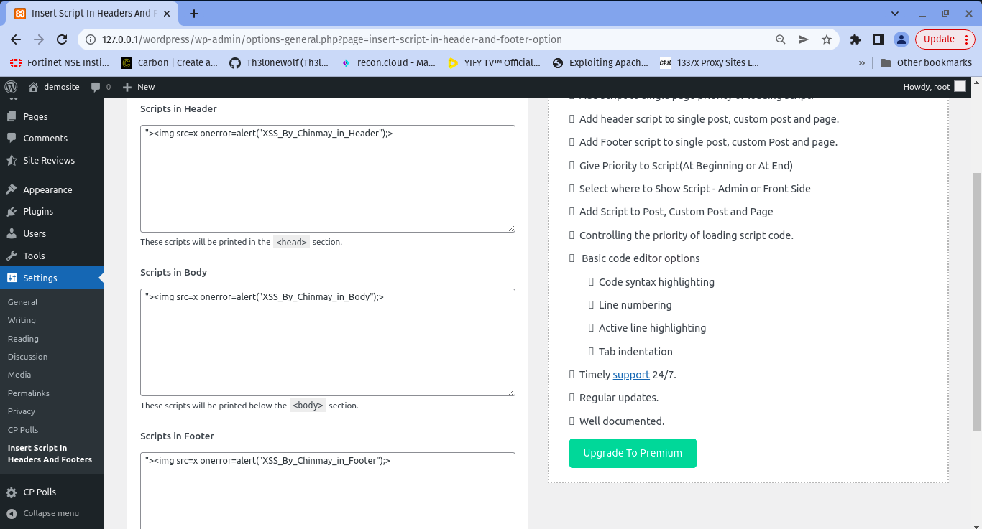

5. You will observe that the payload successfully got stored into the database and when you refresh the website the payload will trigger successfully & we'll get a pop up as per payload defined for header/body/footer section.

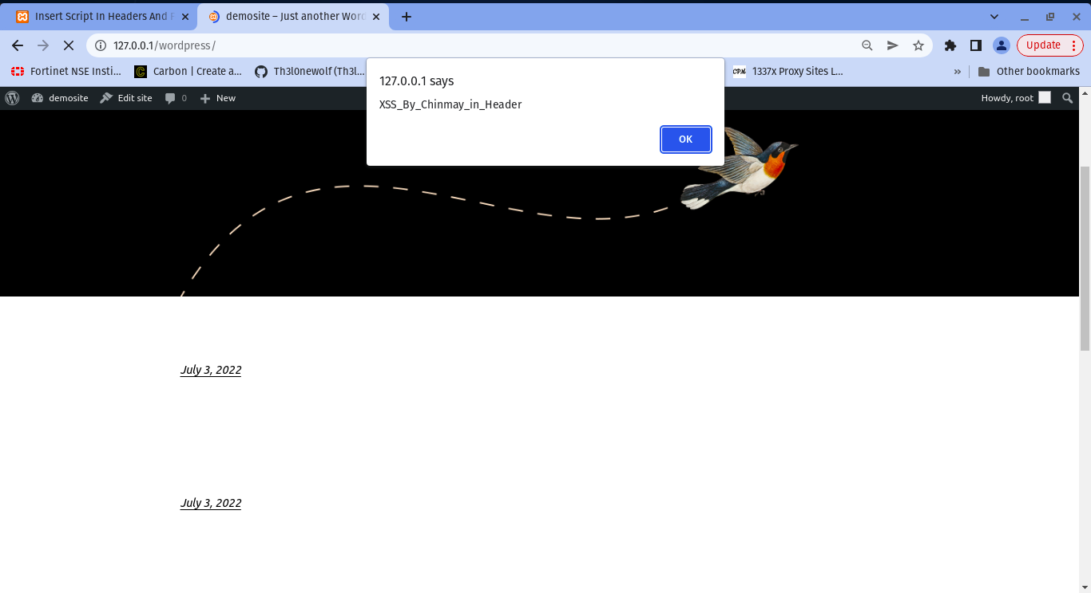

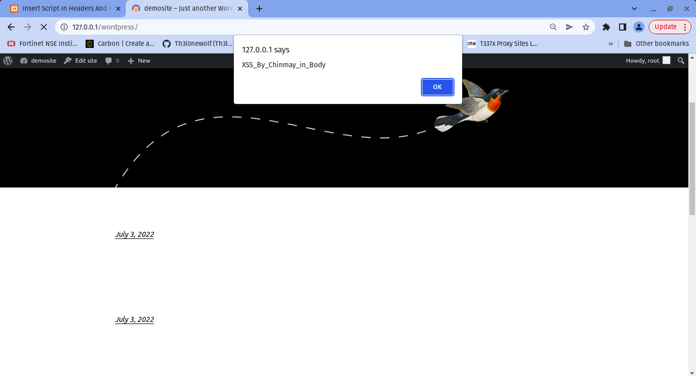

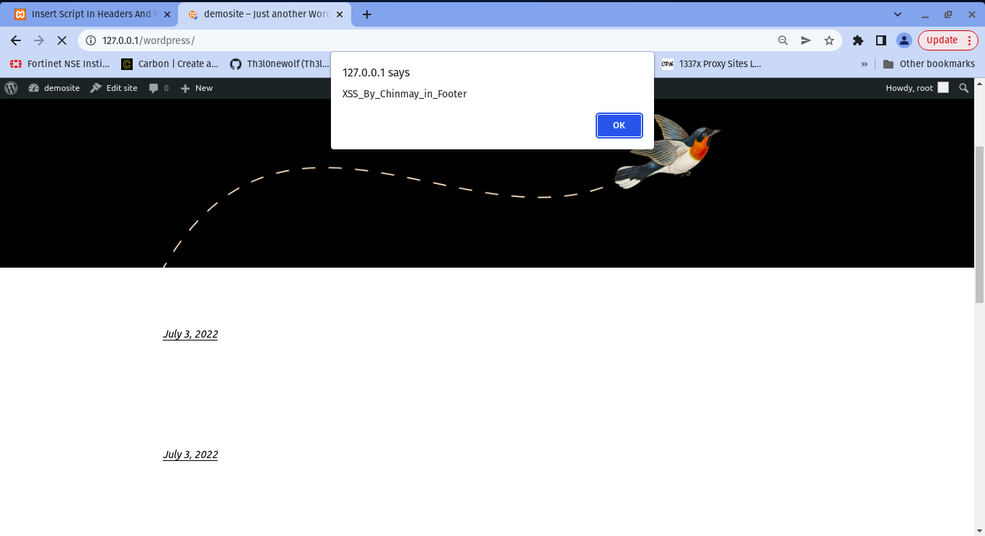

Payload Stored in Data Base

